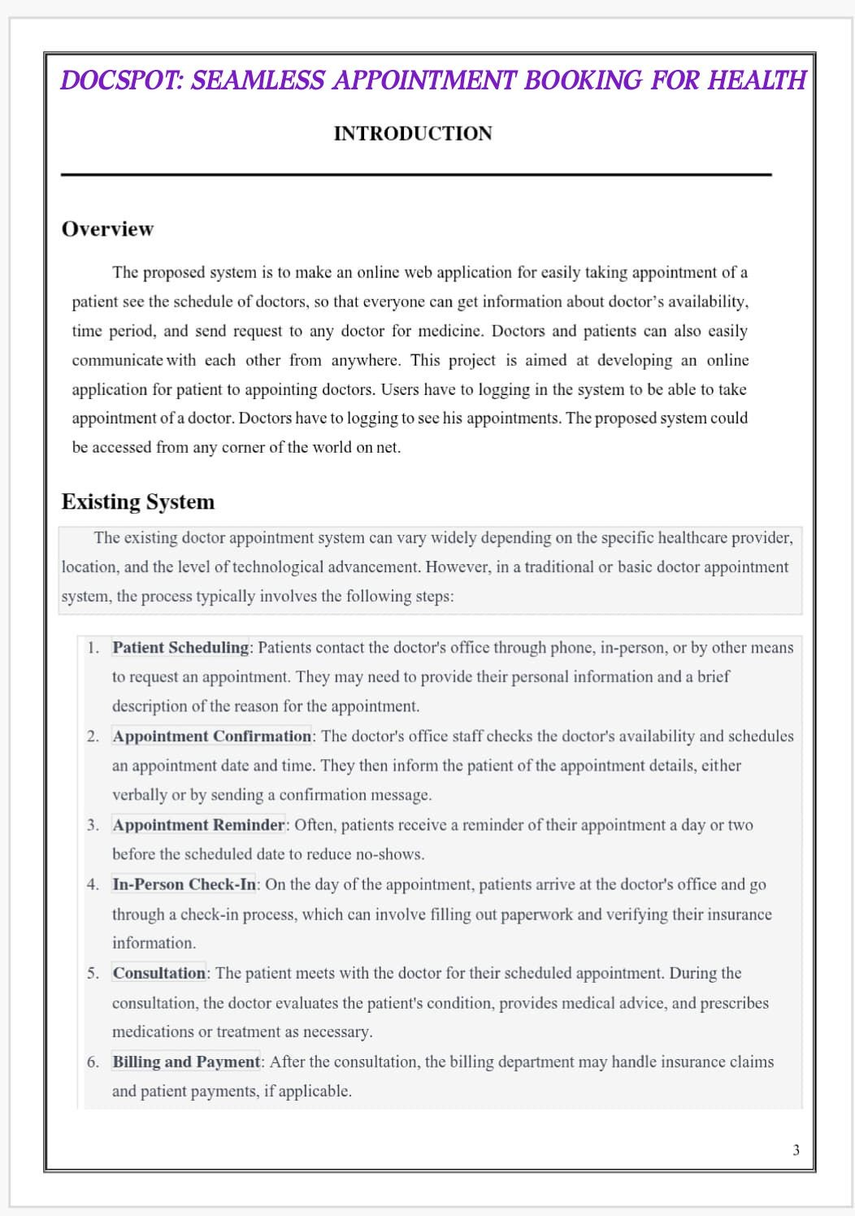

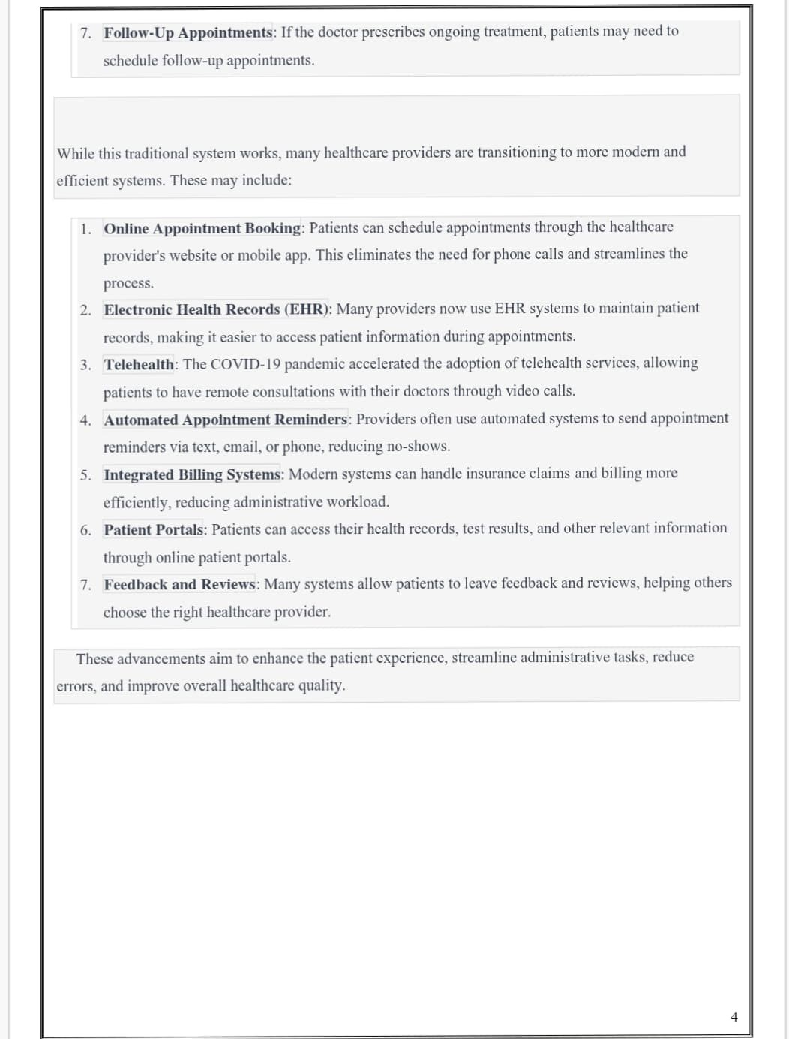

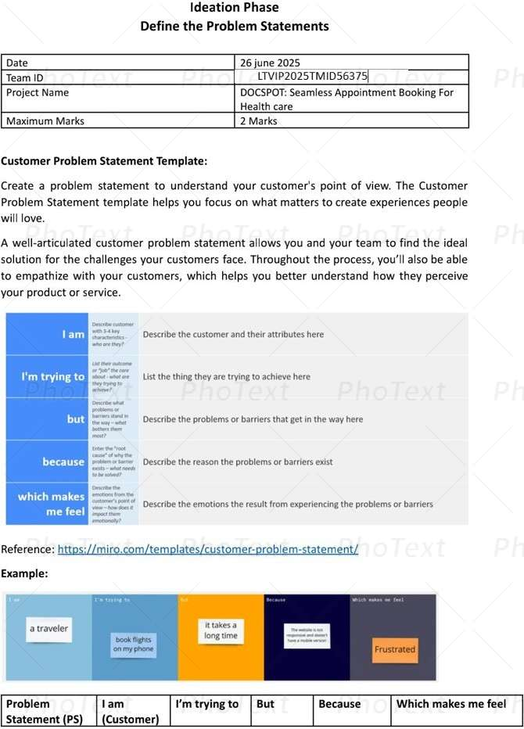

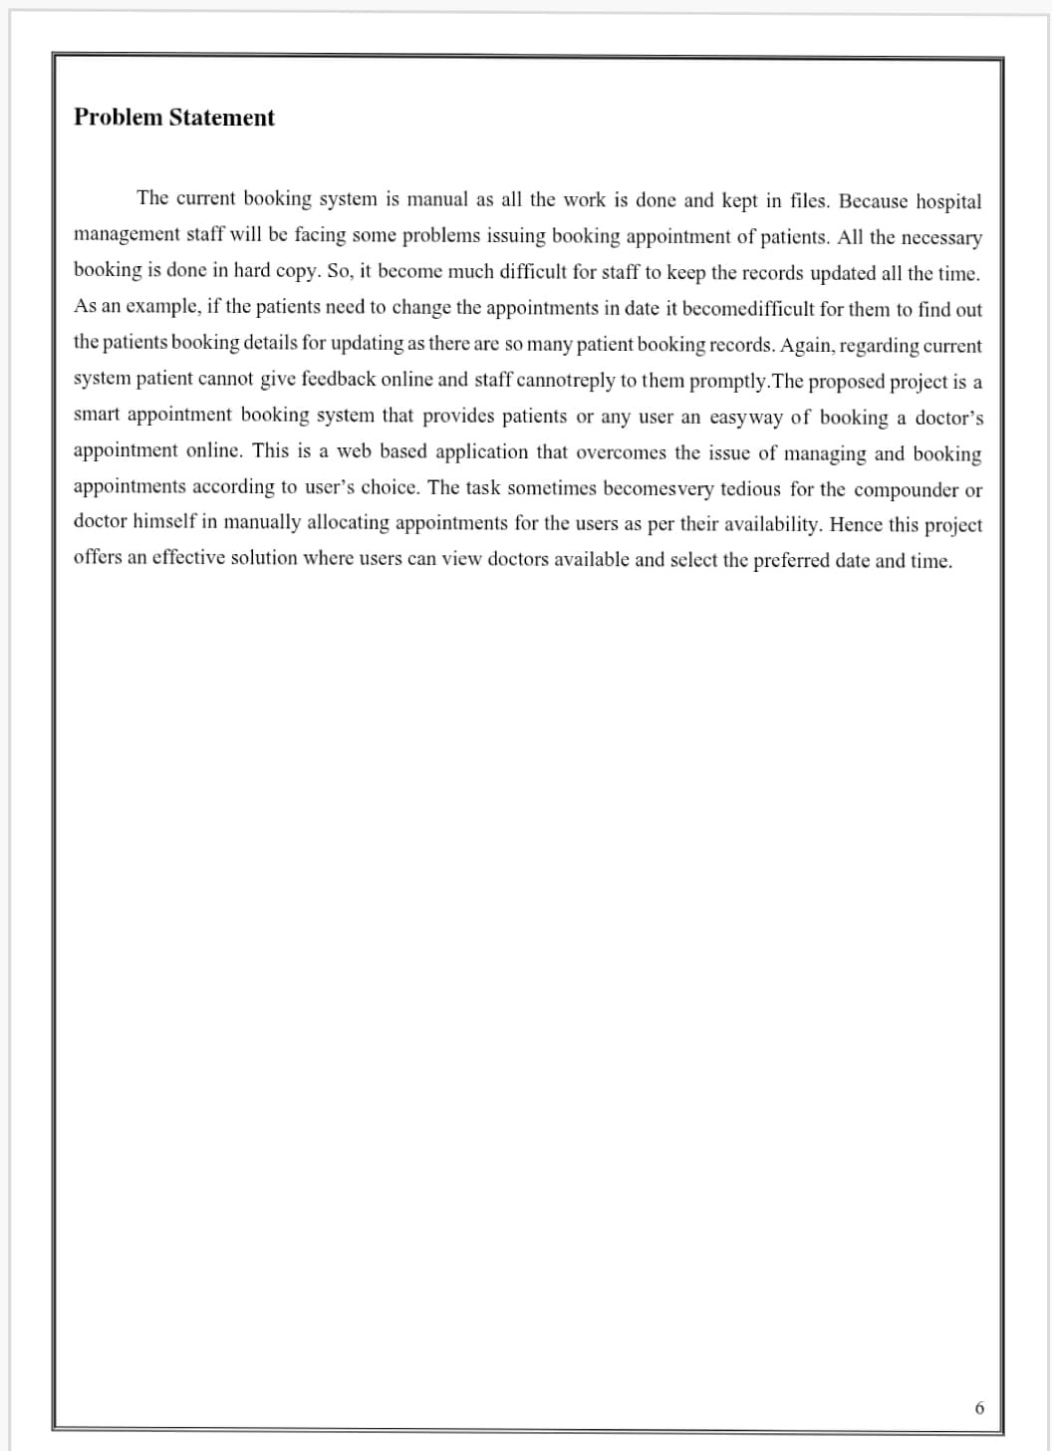

**Ideation Phase**

**Brainstorm & Idea Prioritization Template**

|  |  |
| --- | --- |
| Date | 31 January 2025 |
| Team ID | LTVIP2025TMID56375 |
| Project Name | DocSpot: Seamless Appointment Booking for Health |
| Maximum Marks | 4 Marks |

**Brainstorm & Idea Prioritization Template:**

Brainstorming provides a free and open environment that encourages everyone within a team to participate in the creative thinking process that leads to problem solving. Prioritizing volume over value, out-of-the-box ideas are welcome and built upon, and all participants are encouraged to collaborate, helping each other develop a rich amount of creative solutions.

Use this template in your own brainstorming sessions so your team can unleash their imagination and start shaping concepts even if you're not sitting in the same room.

Reference: <https://www.mural.co/templates/brainstorm-and-idea-prioritization>

**Step-1: Team Gathering, Collaboration and Select the Problem Statement**

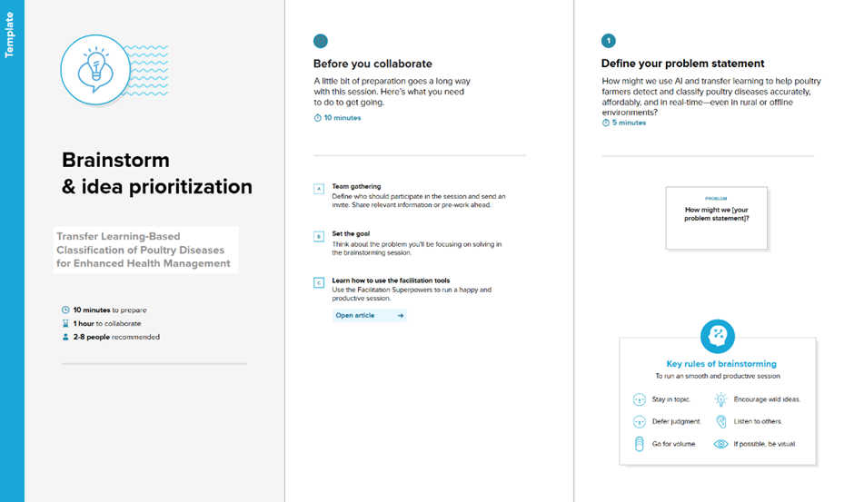

**Step-2: Brainstorm, Idea Listing and Grouping**

**Step-3: Idea Prioritization**

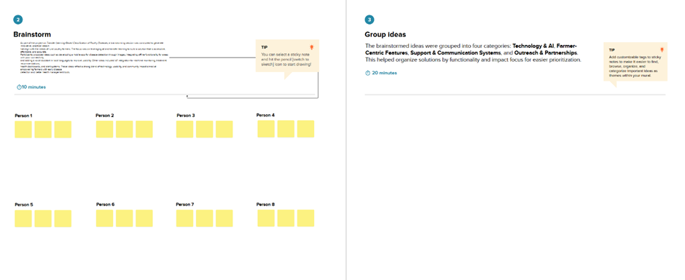

**Step-3: Idea Prioritization**

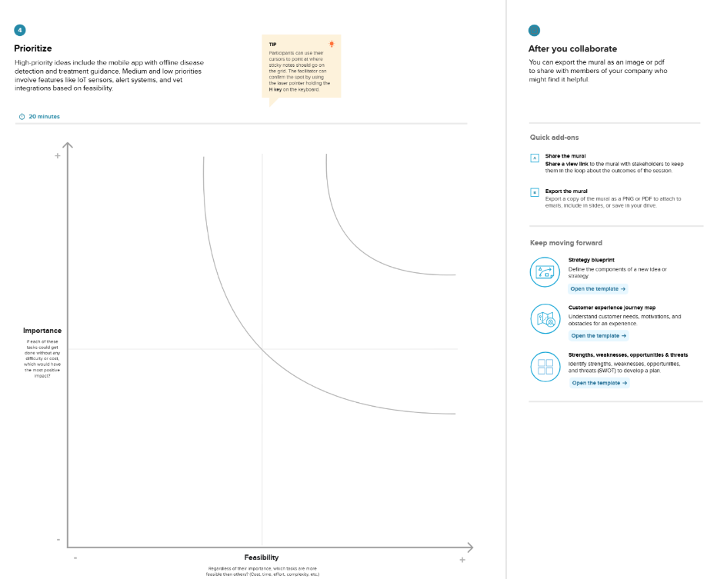

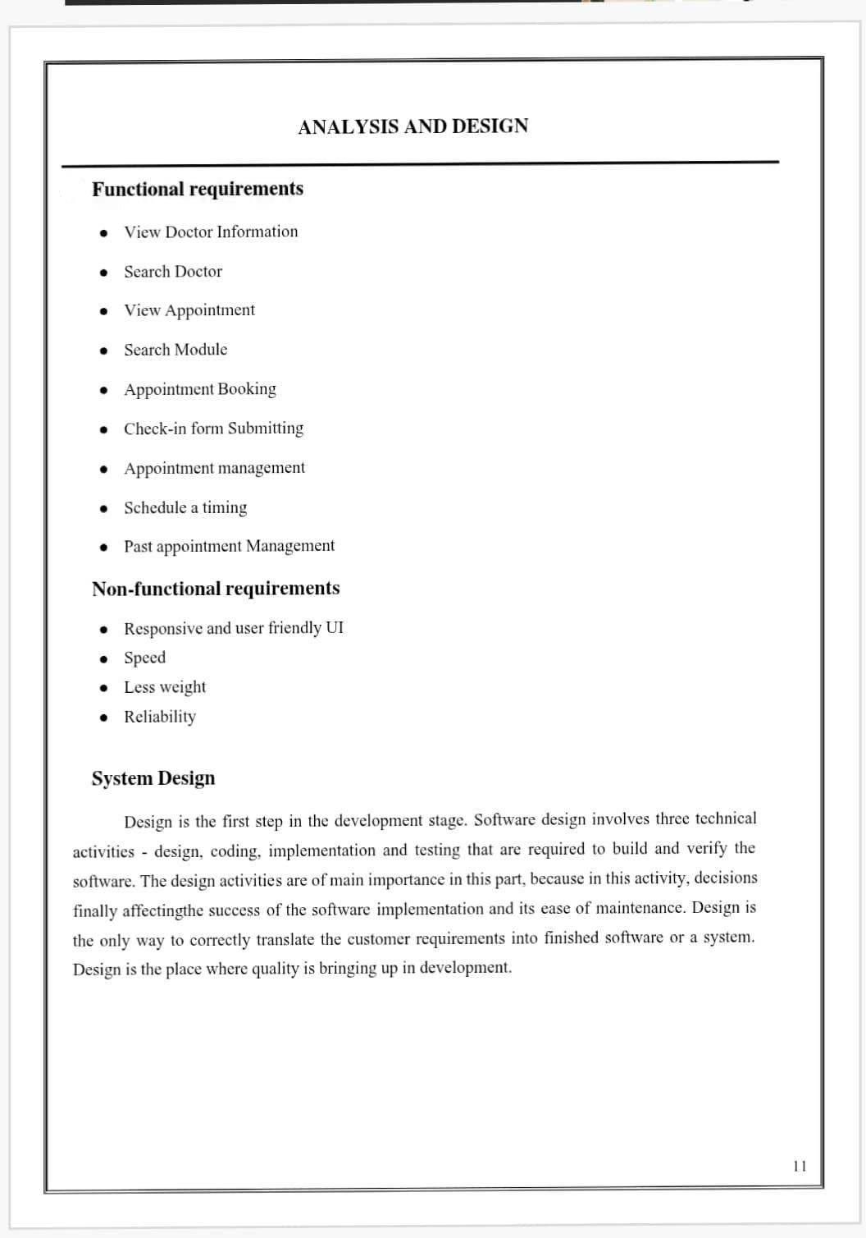

**Project Design Phase-II**

**Solution Requirements (Functional & Non-functional)**

|  |  |
| --- | --- |
| **Date** | 31 January 2025 |
| **Team ID** | LTVIP2025TMID56375 |
| **Project Name** | DocSpot: Seamless Appointment Booking for Health |
| **Maximum Marks** | 4 Marks |

**Functional Requirements:**

**Following are the functional requirements of the proposed solution.**

|  |  |  |
| --- | --- | --- |
| **FR No.** | **Functional Requirement (Epic)** | **Sub Requirement (Story / Sub-Task)** |
| **FR-1** | **User Registration** | Registration through Form  Registration through Gmail  Registration through LinkedIN |
| **FR-2** | **User Confirmation** | Confirmation via Email  Confirmation via OTP |
| **FR-3** | **User login** | Login with ID |
| **FR-4** | **Admin Login** | Login with ID |
|  |  |  |
|  |  |  |

**Non-functional Requirements:**

**Following are the non-functional requirements of the proposed solution.**

|  |  |  |
| --- | --- | --- |
| **FR No.** | **Non-Functional Requirement** | **Description** |
| **NFR-1** | **Usability** | The doctor Appointment app fature a simple and intuitive design ,making it easy for users to negative |
| **NFR-2** | **Security** | The doctor Appointment app fature a simple and intuitive design ,making it easy for users to negative interfeace of the performance |
| **NFR-3** | **Reliability** | The doctor Appointment app fature a simple and intuitive design ,making it easy for users to infrastures |
| **NFR-4** | **Performance** | The doctor Appointment app delievers high performance |
| **NFR-5** | **Availability** | The doctor Appointment app designed to be highly performance |
| **NFR-6** | **Scalability** | The doctor Appointment app fature a simple and intuitive design ,making it easy for users dependent apointments |

**Project Design Phase-II**

**Data Flow Diagram & User Stories**

|  |  |
| --- | --- |
| **Date** | 31 January 2025 |
| **Team ID** | LTVIP2025TMID56375 |
| **Project Name** | DocSpot: Seamless Appointment Booking for Health |
| **Maximum Marks** | 4 Marks |

**Data Flow Diagrams:**

A Data Flow Diagram (DFD) is a traditional visual representation of the information flows within a system. A neat and clear DFD can depict the right amount of the system requirement graphically. It shows how data enters and leaves the system, what changes the information, and where data is **stored. Diagram, timeline
**

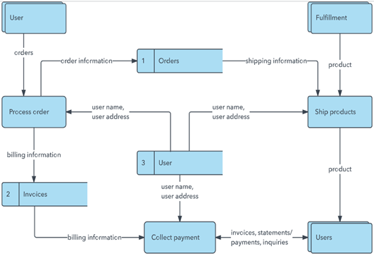**User Stories**

**Use the below template to list all the user stories for the product.**

| **User Type** | **Functional Requirement (Epic)** | **User Story Number** | **User Story / Task** | **Acceptance criteria** | **Priority** | **Release** |
| --- | --- | --- | --- | --- | --- | --- |
| Customer (Mobile user) | Registration | USN-1 | As a user, I can register for the application by entering my email, password, and confirming my password. | I can access my account / dashboard | High | **Sprint-1** |
|  |  | USN-2 | As a user, I will receive confirmation email once I have registered for the application | I can receive confirmation email & click confirm | High | **Sprint-1** |
|  |  | USN-3 | As a user, I can register for the application through Facebook | I can register & access the dashboard with Facebook Login | Low | **Sprint-2** |
|  |  | USN-4 | As a user, I can register for the application through Gmail |  | Medium | **Sprint-1** |
|  | Login | USN-5 | As a user, I can log into the application by entering email & password |  | High | **Sprint-1** |
|  | Dashboard |  |  |  |  |  |
| Customer (Web user) |  |  |  |  |  |  |
| Customer Care Executive |  |  |  |  |  |  |

**Project Design Phase-II**

**Technology Stack (Architecture & Stack)**

|  |  |
| --- | --- |
| **Date** | 31 January 3035 |
| **Team ID** | LTVIP2025TMID56375 |
| **Project Name** | DocSpot: Seamless Appointment Booking for Health |
| **Maximum Marks** | 4 Marks |

**Technical Architecture:**

The Deliverable shall include the architectural diagram as below and the information as per the table1 & table 2

Example: Order processing during pandemics for offline mode

**Reference:** [**https://developer.ibm.com/patterns/ai-powered-backend-system-for-order-processing-during-pandemics/**](https://developer.ibm.com/patterns/ai-powered-backend-system-for-order-processing-during-pandemics/)

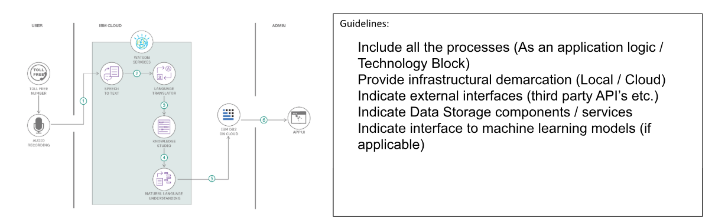

**Table-1 : Components & Technologies:**

|  |  |  |  |
| --- | --- | --- | --- |
| **S.No** | **Component** | **Description** | **Technology** |
|  | **User Interface** | How user interacts with application e.g.  Web UI, Mobile App, Chatbot etc. | HTML, CSS, JavaScript / Angular Js / React Js etc. |
|  | **Application Logic-1** | Logic for a process in the application | Java / Python |
|  | **Application Logic-2** | Logic for a process in the application | IBM Watson STT service |
|  | **Application Logic-3** | Logic for a process in the application | IBM Watson Assistant |
|  | **Database** | Data Type, Configurations etc. | MySQL, NoSQL, etc. |
|  | **Cloud Database** | Database Service on Cloud | IBM DB2, IBM Cloudant etc. |
|  | **File Storage** | File storage requirements | IBM Block Storage or Other Storage Service or Local Filesystem |
|  | **External API-1** | Purpose of External API used in the application | IBM Weather API, etc. |
|  | **External API-2** | Purpose of External API used in the application | Aadhar API, etc. |
|  | **Machine Learning Model** | Purpose of Machine Learning Model | Object Recognition Model, etc. |
|  | **Infrastructure (Server / Cloud)** | Application Deployment on Local System / Cloud  Local Server Configuration:  Cloud Server Configuration : | Local, Cloud Foundry, Kubernetes, etc. |

**Table-2: Application Characteristics:**

| **S.No** | **Characteristics** | **Description** | **Technology** |
| --- | --- | --- | --- |
|  | **Open-Source Frameworks** | List the open-source frameworks used | Technology of Opensource framework |
|  | **Security Implementations** | List all the security / access controls implemented, use of firewalls etc. | e.g. SHA-256, Encryptions, IAM Controls, OWASP etc. |
|  | **Scalable Architecture** | Justify the scalability of architecture (3 – tier, Micro-services) | Technology used |
|  | **Availability** | Justify the availability of application (e.g. use of load balancers, distributed servers etc.) | Technology used |
|  | **Performance** | Design consideration for the performance of the application (number of requests per sec, use of Cache, use of CDN’s) etc. | Technology used |

**References:**

[**https://c4model.com/**](https://c4model.com/)

[**https://developer.ibm.com/patterns/online-order-processing-system-during-pandemic/**](https://developer.ibm.com/patterns/online-order-processing-system-during-pandemic/)

[**https://www.ibm.com/cloud/architecture**](https://www.ibm.com/cloud/architecture)

[**https://aws.amazon.com/architecture**](https://aws.amazon.com/architecture)

[**https://medium.com/the-internal-startup/how-to-draw-useful-technical-architecture-diagrams-2d20c9fda90d**](https://medium.com/the-internal-startup/how-to-draw-useful-technical-architecture-diagrams-2d20c9fda90d)

**Project Design Phase**

**Problem – Solution Fit Template**

|  |  |
| --- | --- |
| **Date** | 15 February 2025 |
| **Team ID** | LTVIP2025TMID56375 |
| **Project Name** | DocSpot: Seamless Appointment Booking for Health |
| **Maximum Marks** | 2 Marks |

**Problem – Solution Fit Template:**

The Problem-Solution Fit simply means that you have found a problem with your customer and that the solution you have realized for it actually solves the customer’s problem. It helps entrepreneurs, marketers and corporate innovators identify behavioral patterns and recognize what would work and why

**Purpose:**

* Solve complex problems in a way that fits the state of your customers.
* Succeed faster and increase your solution adoption by tapping into existing mediums and channels of behavior.
* Sharpen your communication and marketing strategy with the right triggers and messaging.
* Increase touch-points with your company by finding the right problem-behavior fit and building trust by solving frequent annoyances, or urgent or costly problems.
* Understand the existing situation in order to improve it for your target group.
* Calendar

  Description automatically generated

References:

1. <https://www.ideahackers.network/problem-solution-fit-canvas/>
2. <https://medium.com/@epicantus/problem-solution-fit-canvas-aa3dd59cb4fe>

**Project Design Phase**

## Proposed Solution Template

|  |  |
| --- | --- |
| **Date** | 15 February 2025 |
| **Team ID** | LTVIP2025TMID56375 |
| **Project Name** | DocSpot: Seamless Appointment Booking for Health |
| **Maximum Marks** | 2 Marks |

**Proposed Solution Template:**

Project team shall fill the following information in the proposed solution template.

|  |  |  |
| --- | --- | --- |
| **S.No.** | **Parameter** | **Description** |
|  | Problem Statement (Problem to be solved) |  |
|  | Idea / Solution description |  |
|  | Novelty / Uniqueness |  |
|  | Social Impact / Customer Satisfaction |  |
|  | Business Model (Revenue Model) |  |
|  | Scalability of the Solution |  |

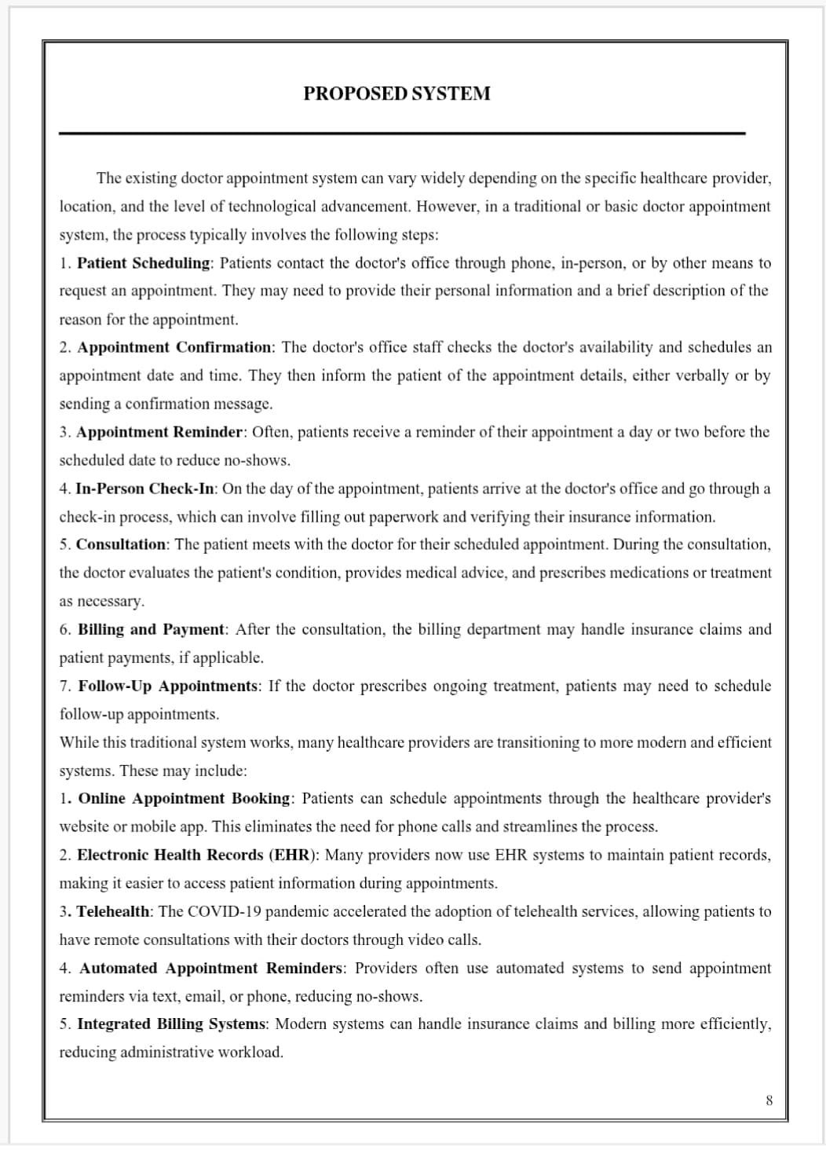

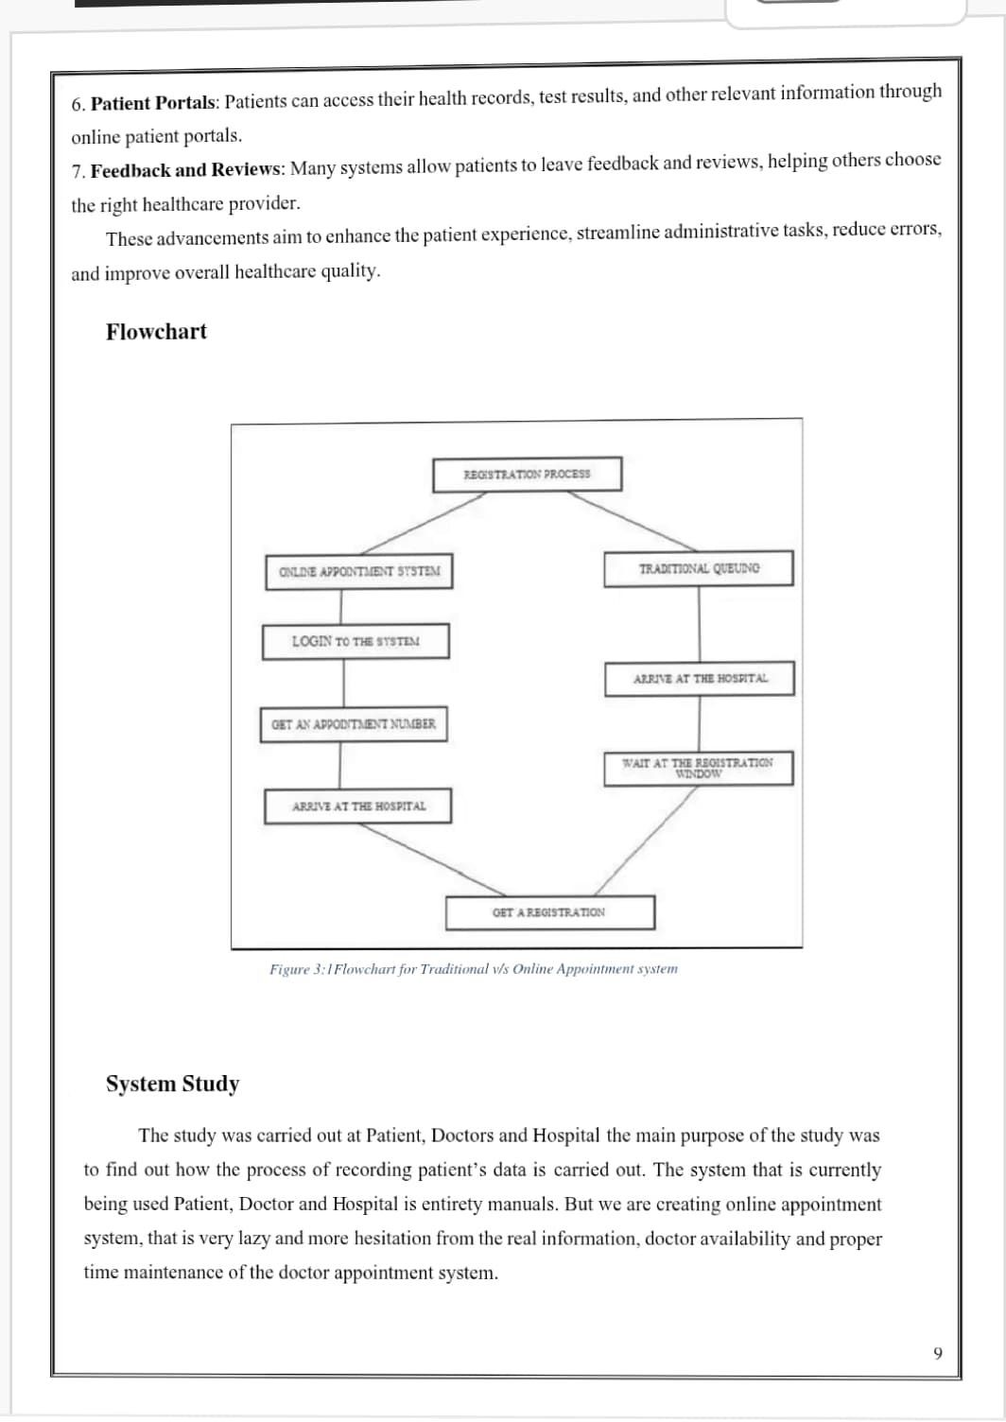

**Project Design Phase**

**Solution Architecture**

|  |  |
| --- | --- |
| **Date** | 15 February 2025 |
| **Team ID** | LTVIP2025TMID56375 |
| **Project Name** | DocSpot: Seamless Appointment Booking for Health |
| **Maximum Marks** | 4 Marks |

**Solution Architecture:**

Solution architecture is a complex process – with many sub-processes – that bridges the gap between business problems and technology solutions. Its goals are to:

* Find the best tech solution to solve existing business problems.
* Describe the structure, characteristics, behavior, and other aspects of the software to project stakeholders.
* Define features, development phases, and solution requirements.
* Provide specifications according to which the solution is defined, managed, and delivered.

**Example - Solution Architecture Diagram:**

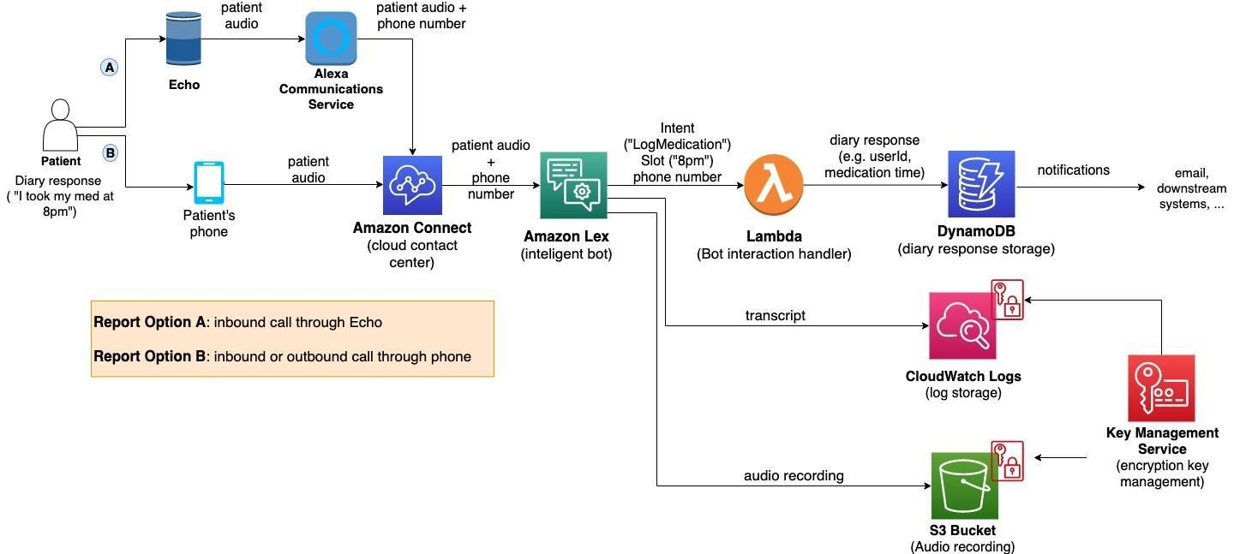

**Project Planning Phase**

Project Planning Template (Product Backlog, Sprint Planning, Stories, Story points**)**

|  |  |
| --- | --- |
| **Date** | 15 February 2025 |
| **Team ID** | LTVIP2025TMID56375 |
| **Project Name** | DocSpot: Seamless Appointment Booking for Health |
| **Maximum Marks** | 5 Marks |

**Product Backlog, Sprint Schedule, and Estimation (4 Marks)**

Use the below template to create product backlog and sprint schedule

| **Sprint** | **Functional Requirement (Epic)** | **User Story Number** | **User Story / Task** | **Story Points** | **Priority** | **Team Members** |
| --- | --- | --- | --- | --- | --- | --- |
| Sprint-1 | Registration | USN-1 | As a user, I can register for the application by entering my email, password, and confirming my password. | 2 | High |  |
| Sprint-1 |  | USN-2 | As a user, I will receive confirmation email once I have registered for the application | 1 | High |  |
| Sprint-2 |  | USN-3 | As a user, I can register for the application through Facebook | 2 | Low |  |
| Sprint-1 |  | USN-4 | As a user, I can register for the application through Gmail | 2 | Medium |  |
| Sprint-1 | Login | USN-5 | As a user, I can log into the application by entering email & password | 1 | High |  |
|  | Dashboard |  |  |  |  |  |
|  |  |  |  |  |  |  |
|  |  |  |  |  |  |  |

**Project Tracker, Velocity & Burndown Chart: (4 Marks)**

| **Sprint** | **Total Story Points** | **Duration** | **Sprint Start Date** | **Sprint End Date (Planned)** | **Story Points Completed (as on Planned End Date)** | **Sprint Release Date (Actual)** |
| --- | --- | --- | --- | --- | --- | --- |
| Sprint-1 | 20 | 6 Days | 24 Oct 2022 | 29 Oct 2022 | 20 | 29 Oct 2022 |
| Sprint-2 | 20 | 6 Days | 31 Oct 2022 | 05 Nov 2022 |  |  |
| Sprint-3 | 20 | 6 Days | 07 Nov 2022 | 12 Nov 2022 |  |  |
| Sprint-4 | 20 | 6 Days | 14 Nov 2022 | 19 Nov 2022 |  |  |
|  |  |  |  |  |  |  |
|  |  |  |  |  |  |  |
|  |  |  |  |  |  |  |
|  |  |  |  |  |  |  |

**Velocity:**

Imagine we have a 10-day sprint duration, and the velocity of the team is 20 (points per sprint). Let’s calculate the team’s average velocity (AV) per iteration unit (story points per day)

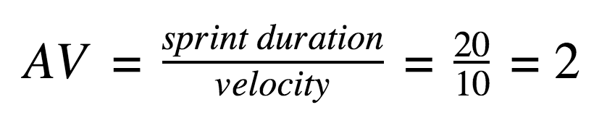

**Burndown Chart:**

A burn down chart is a graphical representation of work left to do versus time. It is often used in agile[software development](https://www.visual-paradigm.com/scrum/what-is-agile-software-development/) methodologies such as [Scrum](https://www.visual-paradigm.com/scrum/scrum-in-3-minutes/). However, burn down charts can be applied to any project containing measurable progress over time.

[**https://www.visual-paradigm.com/scrum/scrum-burndown-chart/**](https://www.visual-paradigm.com/scrum/scrum-burndown-chart/)

[**https://www.atlassian.com/agile/tutorials/burndown-charts**](https://www.atlassian.com/agile/tutorials/burndown-charts)

**Reference:**

[**https://www.atlassian.com/agile/project-management**](https://www.atlassian.com/agile/project-management)

[**https://www.atlassian.com/agile/tutorials/how-to-do-scrum-with-jira-software**](https://www.atlassian.com/agile/tutorials/how-to-do-scrum-with-jira-software)

[**https://www.atlassian.com/agile/tutorials/epics**](https://www.atlassian.com/agile/tutorials/epics)

[**https://www.atlassian.com/agile/tutorials/sprints**](https://www.atlassian.com/agile/tutorials/sprints)

[**https://www.atlassian.com/agile/project-management/estimation**](https://www.atlassian.com/agile/project-management/estimation)

[**https://www.atlassian.com/agile/tutorials/burndown-charts**](https://www.atlassian.com/agile/tutorials/burndown-charts)

